Date: 28.02.2025
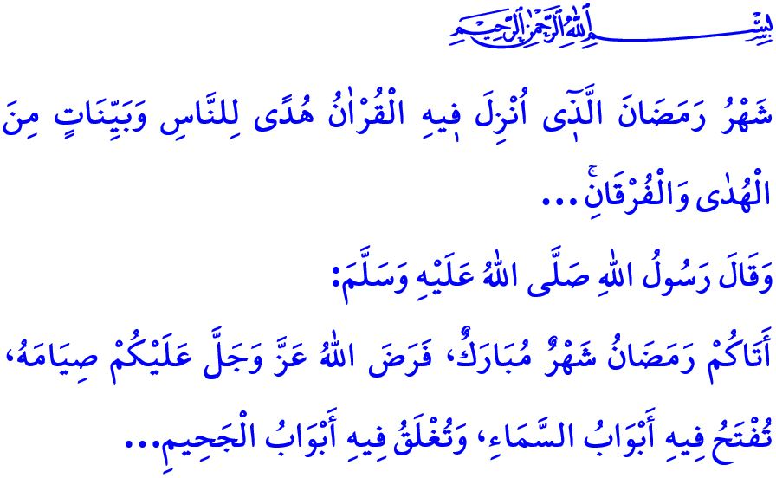
TOWARDS THE SEASON OF MERCY AND FORGIVENESS
Honorable Muslims!
Glad tidings to all of us, and all praise and thanks be to our Lord. The crescent of the holy month of Ramadan will once again rise upon us. With the first tarawih prayer we will perform tonight, we will, inshallah, welcome the season of mercy and forgiveness. Tarawih is a sunnah prayer that our beloved Prophet (saw) performed, led, and encouraged his ummah to practice, and has been practiced in its current form since the time of the Companions. Tarawih is a special act of worship that soothes our weary souls, brings relief to our burdened hearts, and serves as a means for the forgiveness of our sins. Our Prophet (saw) says, “Whoever prayed at night in it (the month of Ramadan) out of sincere faith and hoping for a reward from Allah, then all his previous sins will be forgiven.”
Dear Believers!
Tonight, we will wake up for sahur, the blessed pre-dawn meal of Ramadan, inshallah. The time of sahur is also the time for tahajjud prayer. It is a time for supplication and devotion, repentance and seeking forgiveness. Waking up for sahur is witnessing the awakening of creation. It is leaving sleep behind, setting aside heedlessness, and reviving ourselves with our Lord’s material and spiritual blessings. The Messenger of Allah (saw) says, فَإِنَّ فِى السُّحُورِ بَرَكَةً “There is blessing in sahur.”, and encouraged us to eat sahur, even if only with a sip of water, and gave the glad tidings that those who wake for sahur will receive Allah’s mercy, while the angels will pray for them.
Esteemed Muslims!
Ramadan is the month of fasting. Our Prophet (saw) says, “The blessed month of Ramadan has come. Allah has made fasting during it obligatory upon you. In this month, the gates of Paradise are opened, the gates of Hell are closed...” Fasting during Ramadan is fardh for all Muslims who are mentally sound, have reached puberty, and do not have a valid religious excuse like illness or being on a journey. When observed with its pillars, conditions, and proper etiquette, fasting strengthens our willpower and frees our hearts from selfishness and greed. It safeguards our hands from haram, our tongues from gossip and lie, our worship from hypocrisy, and our hearts from sin. It distances us from Hell and brings us closer to Paradise.
Esteemed Believers!
Ramadan is the month of the Qur’an Our Lord (swt) states, “Ramadan is the month in which the Qur’an was revealed as a guide for humanity with clear proofs of guidance and the decisive authority...” Therefore, let us frequently recite the Holy Qur’an, which makes Ramadan the sultan of the eleven months, reflect on its meaning, and strive even more to embody its teachings in our lives. Let us instill in our children a love for the Qur’an, fasting, prayer, and the mosque. Let us not hurt or discourage our children who come to our mosques, which are places of love and mercy. Let us welcome them with kindness and a warm smile, embracing them within our congregation while ensuring that prayer is performed with tranquility. Let us not deprive them of the mercy, blessings, joy, and spirit of the month of Ramadan.
Dear Muslims!
Ramadan is a time to reflect once again on our responsibilities toward our Lord, ourselves, our families, our surroundings, and humanity. Then let us prepare our hearts, homes, workplaces, streets, villages, towns, and cities for the blessed month of Ramadan. Let us strive to implement Islam’s commands and prohibitions in every aspect of our lives—from eating and drinking to clothing, from shopping to consumption, and from family relations to neighborly ties. Let us not waste our time on entertainments that have no place in our religion or civilization and are incompatible with the spirit of Ramadan. Let us make an effort to perform our worship on time and adjust our schedules according to the times of worship. Let us not set up iftar tables that display luxury and waste, where the needs of the poor are forgotten. Let us extend a helping hand to the oppressed, the poor, the orphan, and the needy, and share our iftar meals with those in need. Let us not use fasting as an excuse to cause hurt feelings, create disturbances, or generate conflict at home, in the workplace, or on the road. Let us not take advantage of others by inflating prices and causing hardship to people. Let us not fill our tables with the products of those who support the oppressors of Muslims.

On this occasion, I pray to the Almighty Allah that this blessed month of Ramadan may be beneficial, first and foremost for our great nation, and for the entire Muslim world and all of humanity.

Ibn Hanbal, VI, 267; Bukhari, I’tisam, 3.
Muwatta’, Ramadan, 2; Tirmidhi, Sawm, 81.
Bukhari, Salah al-Tarawih, 1.
Bukhari, Sawm, 20.
Ibn Hanbal, III, 44.
Nasa’i, Siyam, 5.
Baqarah, 2/185. General Directorate of Religious Services

